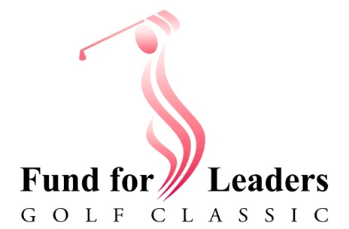
Pr. Kirk Anderson (ret.)
986 N. Maverick Trail
Dewey, AZ 86327

928-420-1422
kirkemm@gmail.com

Dear Working Church, October 3, 2022

Your budget already supports the ELCA Fund for Leaders. A percentage of a percentage of every dollar sent to Synod is apportioned to the Fund. Thank you for being part of a churchwide effort to support seminarians.

Now let’s make it personal.

Here in the Grand Canyon Synod, we dedicate the proceeds of our annual Fund for Leaders appeal to candidates from local congregations. Thanks to the generosity of churches like yours, the synod now provides direct financial support to candidates, when and where it is needed.
These scholarships are timely and effective.
They have made the difference, for some of our candidates,
between staying in seminary or dropping out to make a living.

Please respond to this appeal in one or more ways:

- Find a golfer or four to play in the 11th Annual Fund for Leaders Golf Classic on November 14 at Arrowhead Country Club in Glendale.
- Show your support with a $200 hole sponsorship and put your church on display as shown here from a couple of supporters.

- Post a flyer and include an article in your newsletter to find that special member with a passion for golf AND the future of Being Church.

Please join me in praying for our Grand Canyon Synod seminarians, that they be sustained in their studies, that they come to sustain all of us in their years of ministry ahead.

Pr. Kirk Anderson (retired)
Chair, Fund for Leaders Golf Classic

P.S. We’ve got you covered! Call or email me for Golfer Registration forms, brochures, flyers, and copy/graphics for a newsletter article. We’ll also make your hole sponsor sign.

